Serverless Development 101

**HOP02C – Integrate Serverless Development Tools**

1/10/2019 Developed by Kevin Wang

1/10/2019 Checked by Clark Jason Ngo

1/10/2019 Tested by Tuan Khai and Minh Truong

2/4/2019 Revised by Sam Chung

4/9/2020 Reviewed by Apiwat Chuaphan

Center for Information Assurance (CIAE) @City University of Seattle (CityU)

  

In this activity, we will initialize a NodeJS project, install all dependences, and integrate with Babel and a Linter.

Note:

* Babel is a JavaScript compiler (static analysis tool) that can convert the new syntax code into a backwards compatible version of JavaScript. This will enable JavaScript to run in both current and older browsers and environments. More information: <https://babeljs.io/>
* A linter can help to analyze source code in order to flag programming errors, bugs, stylistic errors, and suspicious constructs. More information: <https://eslint.org/>
* We will use the Airbnb’s JavaScript Style Guide. More information: <https://github.com/airbnb/javascript>

**Learning Outcomes**

* Learn to integrate the NodeJS, Babel, and ESLinter.

**Initialize a NodeJS Project and set up the development environment**

1. Open your terminal (Windows: Windows + R, then “cmd”. MacOS: Command + Space, then “terminal”).
2. Go to your working directory called ‘cs547’ and navigate into the folder.  
   >>> cd /cs547  
   Windows user

>>> dir

Or Mac user

>>> ls

1. Create a folder (with command “mkdir”) and access (with command “cd”) that folder directory.   
   Type in the terminal: (Changed the yourfoldername to the name you want).   
   In this case, we chose ‘**bookstore’**  
   >> mkdir bookstore   
   >> cd bookstore|

1. Open the project in your VSCode.  
   Click the “Open folder” (or from the file menu and click open) and select the folder that we just created.

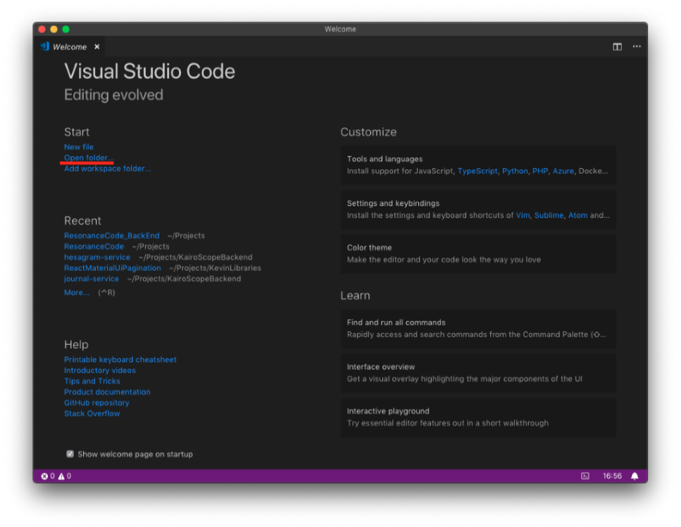

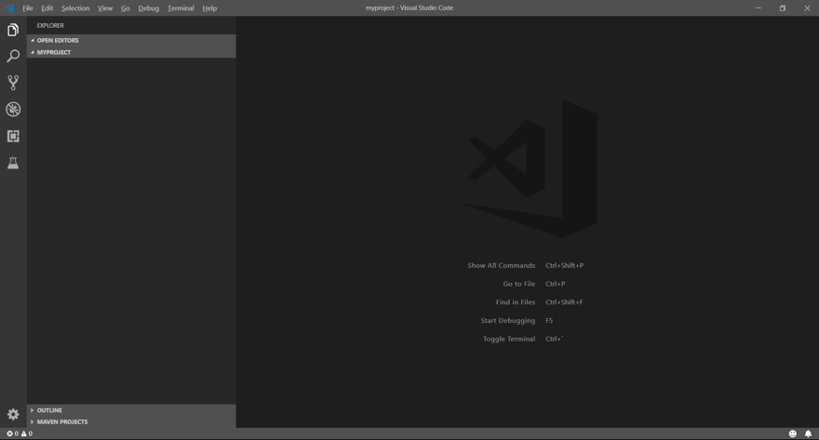

1. Install NPM package dependences.
   1. Create a ‘**package.json**’ file in the root folder, which is **bookstore**

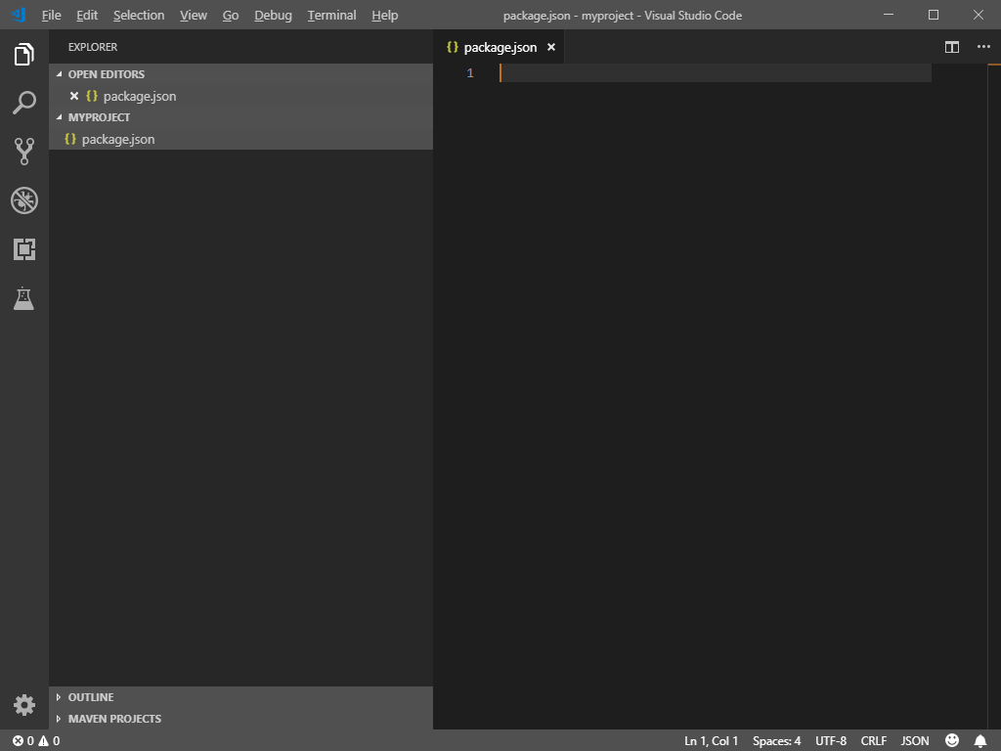

* 1. Copy the content from [here](https://bit.ly/3ebnsEU)Press the “Raw” button” and copy all of them into your ‘package.jason’.

Change the name and author if you want.  
Save your ‘package.json’

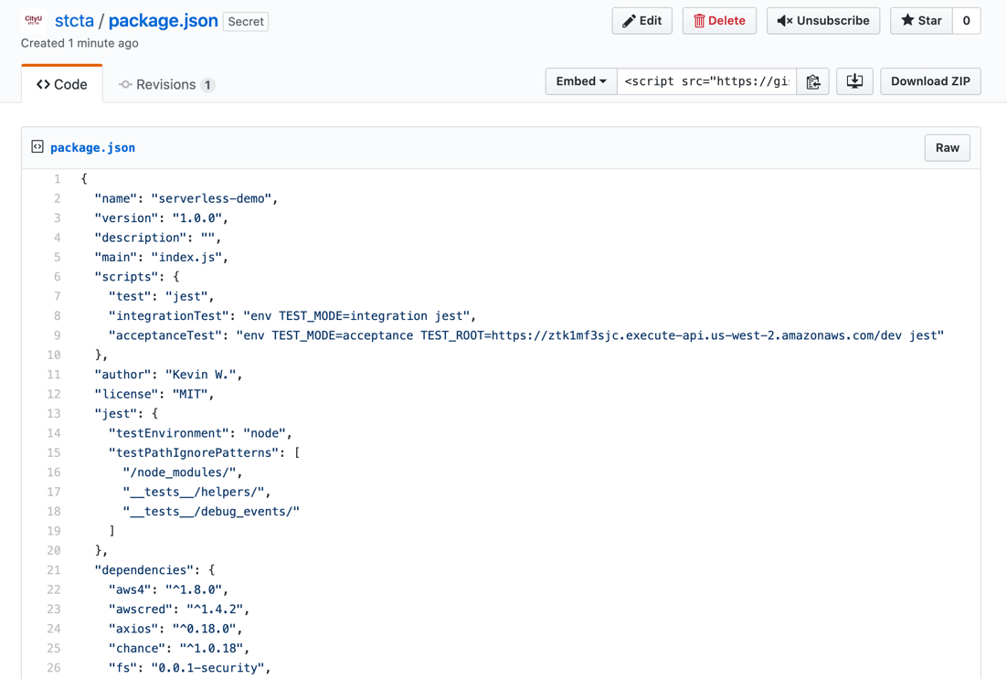

* 1. Open the terminal in the VSCode (shortcut key: control + ~).
  2. Type “**npm**i” in the terminal to install all dependence includes in the ‘package.json’ file.

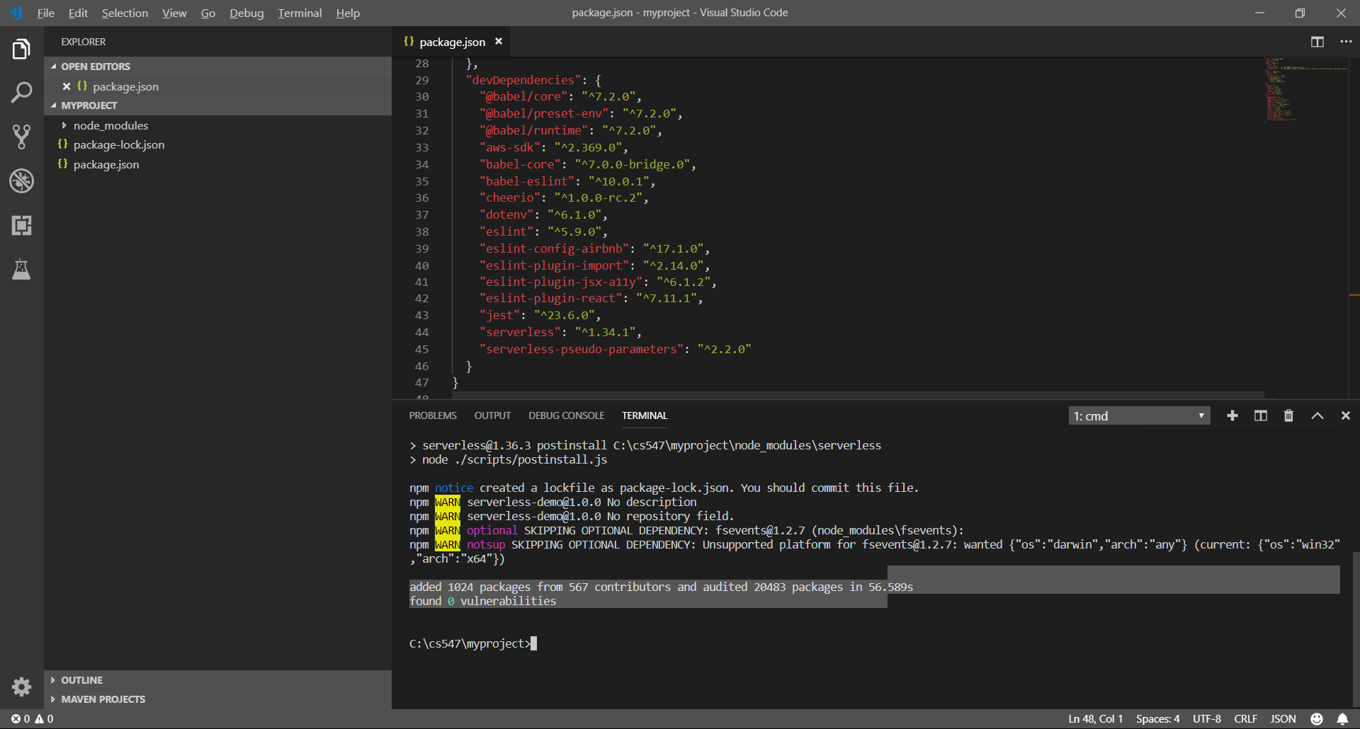

1. Set up a runtime configuration for the babel.   
   Create a ‘.babelrc’ file under the root folder and copy content from <https://bit.ly/2Xn2FY9> to the file.

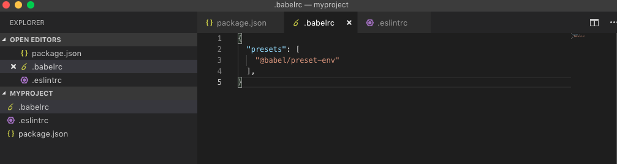

1. Set up a runtime configuration for the eslint.   
   Create a ‘.eslintrc’ file under the root folder and copy content from <https://bit.ly/3eh4mgV> to the file.

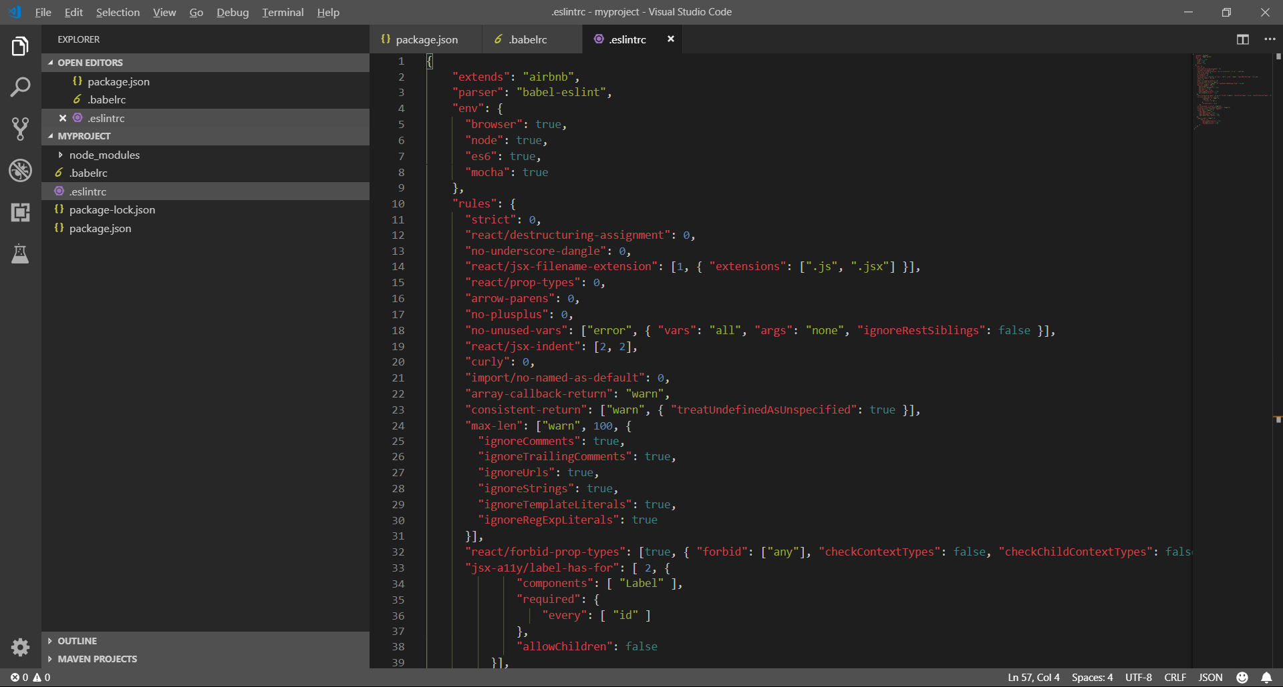

1. Restart your IDE (quit and open VSCode) to enable both the babel and the eslint.

**Push your work to GitHub**

Open the terminal from the VSCode by hit the control + ~ key and type the following command:

Run the following commands to push your work to the GitHub repository:

>>> git add .

>>> git commit -m “Submission for Module 2”

>>> git push origin YOUR_BRANCH_NAME

**Note**: you should change the YOUR_BRANCH_NAME to your own branch name. It should be firstname-lastname (e.g. maria-gracia).

If you cannot remember, run the command “git status” to check